APSI RFIC Study Material
December 29, 2006

- Scope
This documents suggests specifications for a development of APSI’s RFIC in low-IF, zero-IF and super-heterodyne architectures satisfying GMR-1 05.005

- References (provided as attachment sheet)
[1] GMR-1 05.005 “GEO-Mobile Interface Specifications; Part5: Radio interface physical specifications; Sub-part5: Radio Transmission and Reception; GMR-1 05.005”
[2] Datasheet of ADI AD9864, “IF Digitizing Subsystem”
[3] Datasheet of NEC UPC8195K, “TX-IF SiMMIC for WCDMA AGC + I/Q Modulator”
[4] Datasheet of NEC UPC8190K, “RX-IF SiMMIC for WCDMA”
[5] Datasheet of NEC UPG2134TB, “L-band PA Driver Amplifier”
[6] Datasheet of IF-SAW filter B4812

- Abbreviations
GMR : GEO-Mobile Radio
MES : Mobile Earth Station
DDC : Digital Down Converter
SQI : Signal Quality Indicator (=SNR)

- GMR Transmitter Specifications
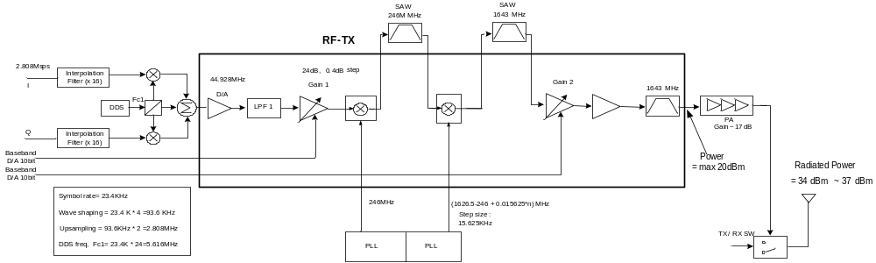
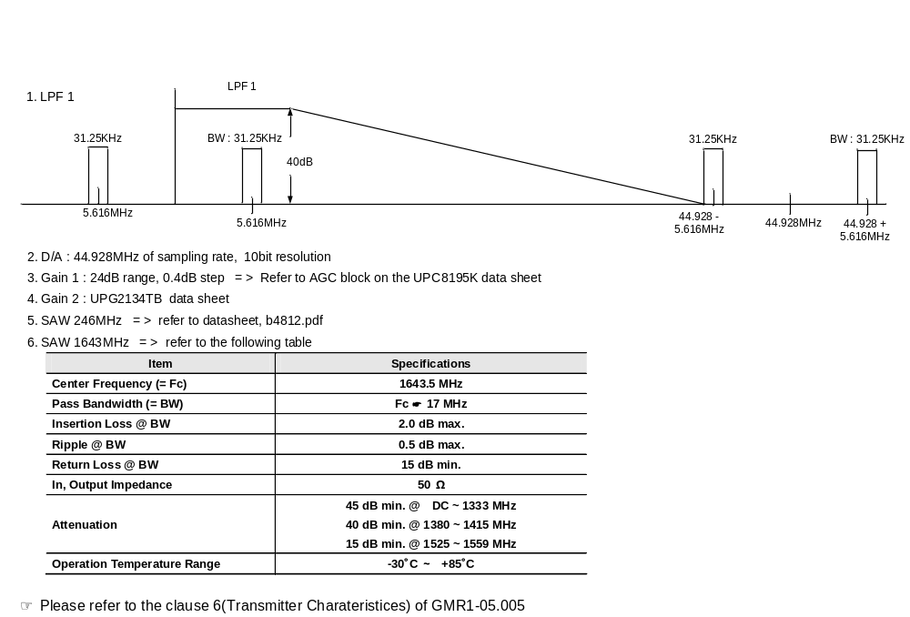

APSI’s comment>> The following two kinds of architectures are being considered as our new RF receiver. Please review them and estimate development schedule and costs.

- Receiver Case A. Direct Conversion
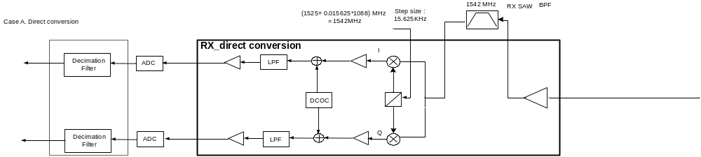
  - LO Phase noise
Frequency offset(kHz) | Expected RF phase noise | Expected IF phase noise
31.25 | -86.6 dBc/Hz | -83.6 dBc/Hz
93.75 | -96.6 dBc/Hz | -93.6 dBc/Hz
>500 | -116.6 dBc/Hz | -113.6 dBc/Hz
LO is fed 13MHz reference clock from VCTCXO

  - Total gain: 60dB. LNA gain should be considered with Receiver Blocking Requirements of clause 6.7

  - LPF
case | Interference relative to sensitivity | Interference frequency offset
1 | +15dB | 31.25kHz
2 | +25dB | 93.75kHz
3 | +45dB | >500kHz

  - RF SAW filter
Characteristic | Frequency Range (MHz) | Value
Insertion loss (max) | 1525 - 1559 | 4.5dB
Amplitude ripple(max) | 1525 – 1559 | 1.5dB
Attenuation (min) | 1480 – 1490 | 40dB
 | 1600 – 1650 | 20dB
 | 2500 – 4000 | 18dB

- Receiver Case B. Low-IF
  - RF Input Signal Level vs. SNR (with compatible RF)
    - G/T : -24 dB/K
    - Antenna Gain : 3.5dBi
    - Room Temperature
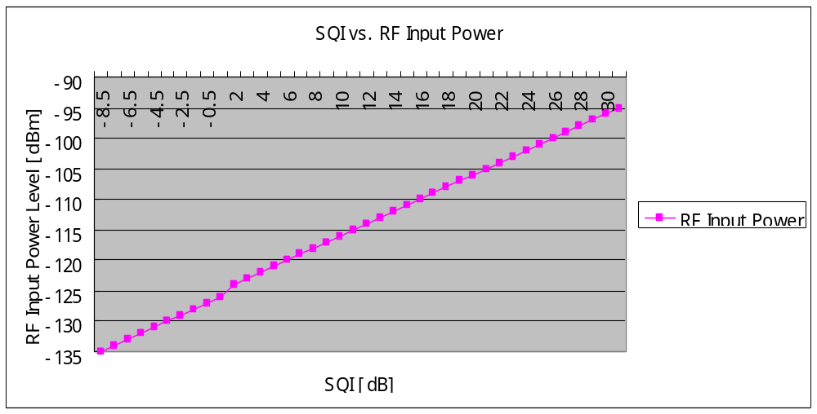
  - Simple Rx Chain Block Diagram
The following two configurations show the two possible configurations of RF Frond-end, assuming that we can modify Cl10084tg that is a Low-IF architecture and Cl7625tg that is an AFE including RX ADC and decimation filter.
    - Possible Configuration #1 with Chipidea’s IPs
      - RF Front-end should have a fixed gain of 60dB.
      - When the ADC is used in the full scale and the dynamic range can be guaranteed as minimum 83dB, AGC is not needed in the receiver.
      - RF Front-end should satisfy the requirements of sensitivity, selectivity, Blocking, Spurious, intermodulation et.al., which are specified in GMR-1 05.005.
      - ADC Requirements
        - Resolution : 16 Bits
        - SFDR : 90dB(min.)
        - Wake-up Time : ?
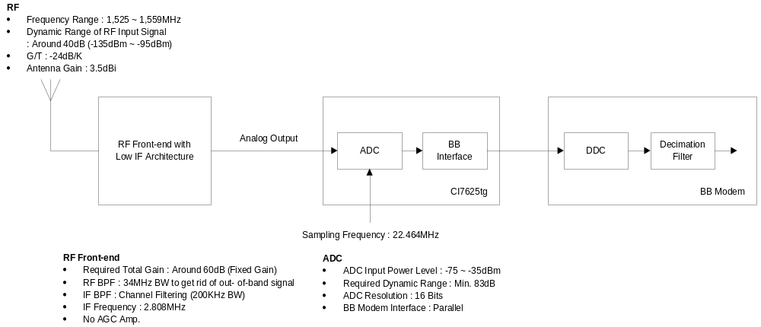
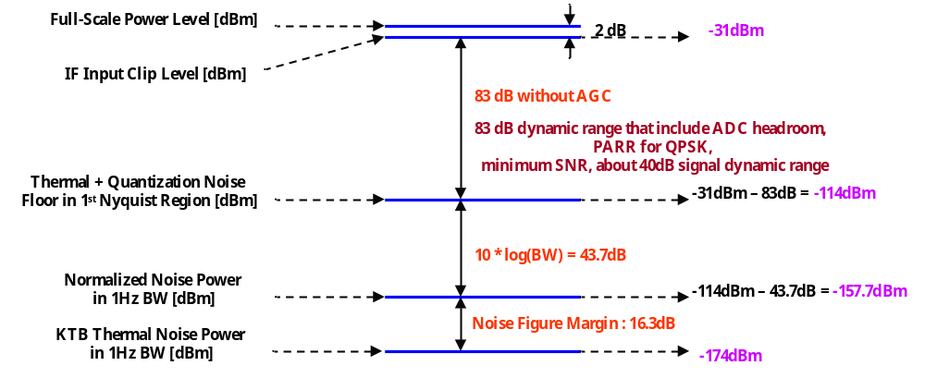 Receiver Budget with AD9864

    - Possible Configuration #2 with Chipidea’s IPs
      - Chipidea is needed to implement I/Q splitter in Cl7625tg.
      - Over sampling rate used in BB modem is four times of symbol rate on each operation mode.
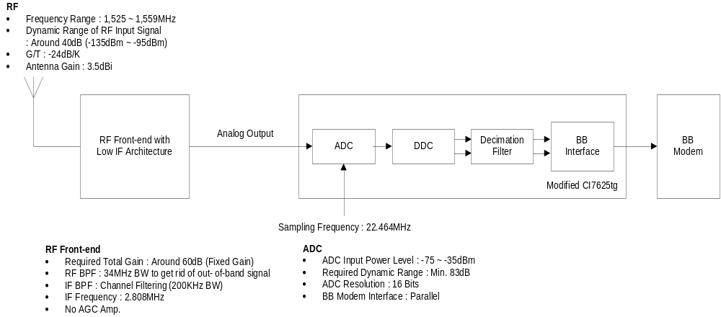

  - Frequency Bands
    - MES Receives : 1,525MHz ~ 1,559MHz
    - MES Transmits : 1,626,5MHz ~ 1,660,5MHz
    - RF Carrier Spacing
 | Carrier Center Frequency | Carrier Number
MES Receive | 1 525 000.00 +31.25 x N | N = 1, 2, 3 ….., 1087

  - Modulation Techniques
    - PI/4-CQPSK/PI/4-DBPSK/6PSK
    - Modulation Symbol Rate
Operation Mode | Symbol Rate [KHz]
Circuit | 23.4
Packet | 46.8

  - Sensitivity Requirement

Sensitivity [dBm] | Required SNR [dB] | BER
-121 dBm | 5.5 dB | 3.5 %
- In case of -135dBm of RF input signal, it will be compensated by channel coding gain and modulation gain.

  - Selectivity requirements
We think selectivity could be a critical issue when we use low-IF or zero-IF. Please make sure the following table.
Case | Interference Level Relative to Sensitivity | Interference Frequency Offset
1 | + 15 dB | 31.25 kHz
2 | + 25 dB | 93.75 kHz
3 | + 45 dB | >500 kHz

  - Blocking Requirements
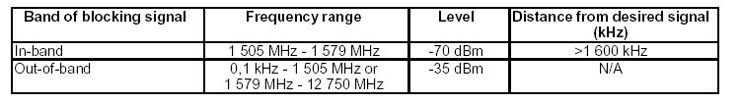
Receiver Blocking Requirement

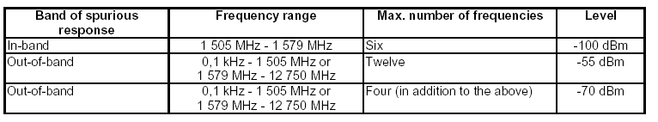
Spurious Response Requirement

  - Frequency Synthesizer
    - Frequency Switching Time
      - Rx to Rx or Tx to Tx : less than 1.6ms
      - Rx to Tx or Tx to Rx : less than 2.2ms
    - Configuration #1: Phase noise characteristics of APSI’s existing design are shown in the following table. RF LO phase noise should be better than the RF noise in the table.
    - Configuration #2: See also the following RF and IF phase noise requirements.

Frequency offset(kHz) | Expected RF phase noise | Expected IF phase noise
31.25 | -86.6 dBc/Hz | -83.6 dBc/Hz
93.75 | -96.6 dBc/Hz | -93.6 dBc/Hz
>500 | -116.6 dBc/Hz | -113.6 dBc/Hz

Interface with BB Modem
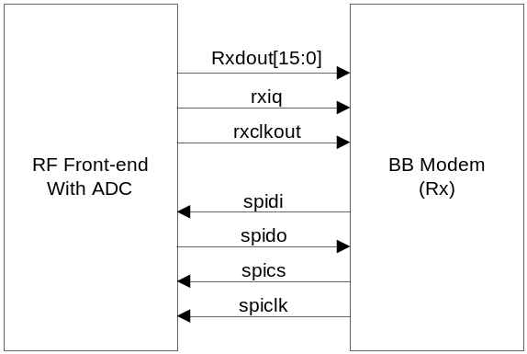

Conclusion and Questions

- Please review the transmitter and two cases of Receiver and give us your estimation of development schedule and costs for the following cases.
  - RFIC including transmitter and receiver. The receiver has 2 cases.
  - RFIC Transmitter alone
  - RFIC Receiver alone (2 cases)
- Node technology for RFIC can be either 0.18um or 0.13um. We will consider cost and power consumption on the decision.

